Rishi Sharma

IT 520

10/29/18

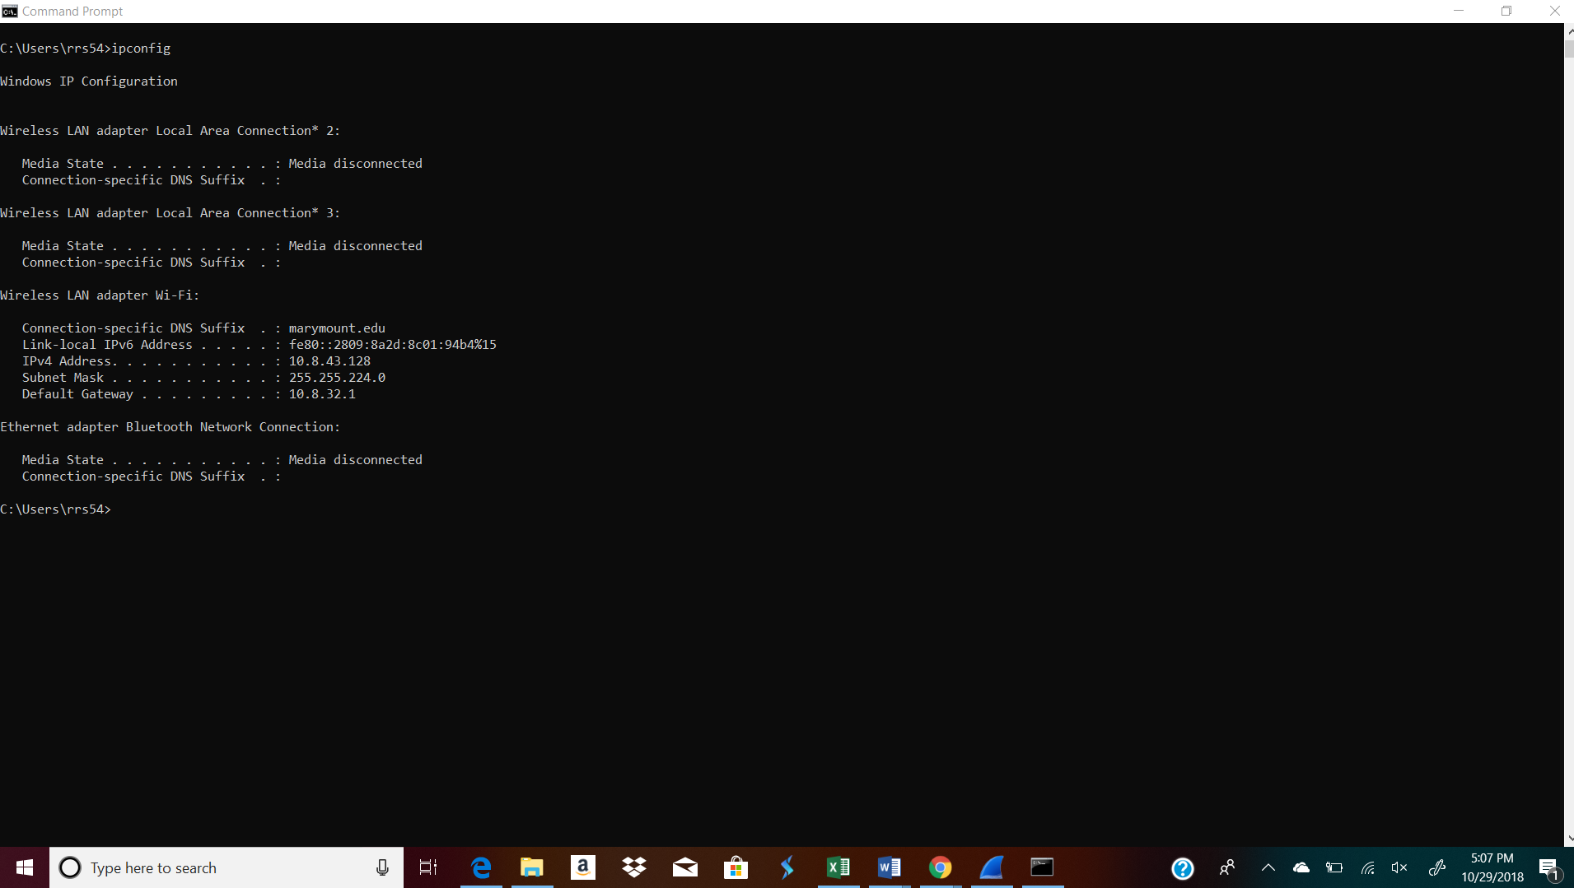

1. Highlighted in Screenshot

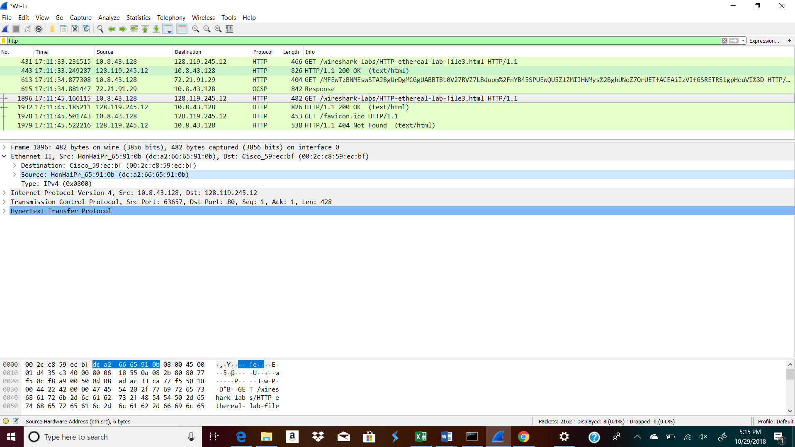

1. Highlighted in Screenshot

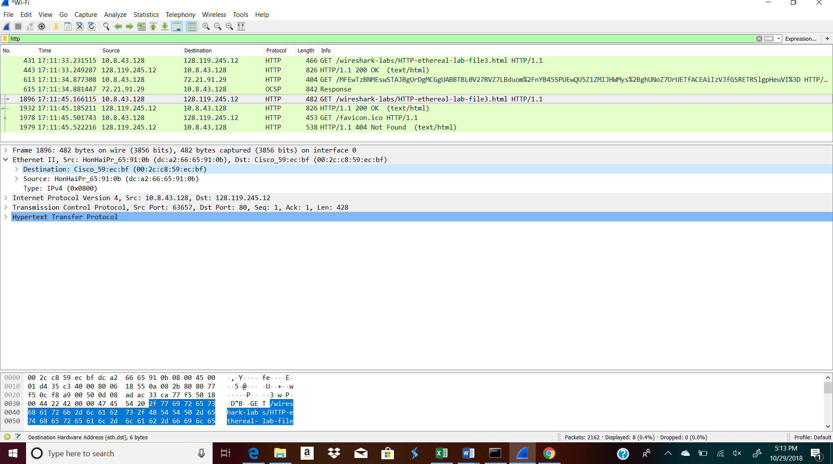

1. It belongs to the cisco router my device is using to connect to the internet.
2. They are both independent and the destination mac address is specific to the router while the destination IP address is more specific to the server
3. Using the terminal (cmd in Windows, Terminal in mac), run a command to display your full ARP list table. (Find out what the command is, and print a full screen shot of your result.)

Arp -a

